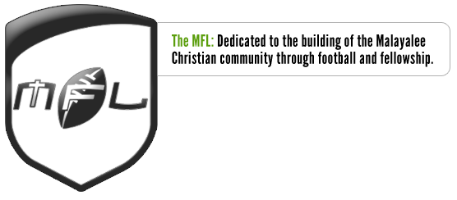

Church Team Merger Request Form

Team Name:

Team Captain:

Church Requesting Merger (Head Church):

Merging Church Team(s) (if more than one church, list all Churches):

Reason for Merger:

Roster of merging Church players with church affiliation:

E.g. (copy and paste from roster spreadsheet is easy option)
1 | Name | Church
2 | John Thomas | St. Mary’s Assembly
3 | Thomas Anthony | St. Mary’s Assembly
4 | Anthony Philip | St. Johns Church of God
.. | .. | ..
15 | Philip Tomas | St. Johns Church of God

Please submit this form to themfl@gmail.com. Upon receipt of this form, the MFL will survey one captain from each team and tally votes to determine if this merger is approved. If approved, the teams may merge. If the merger request is rejected by the Captains' vote, the teams may appeal to the MFL Board for approval. Approval of church team mergers through this request form (through Captains' vote or the MFL Board) is valid only for the application year.

